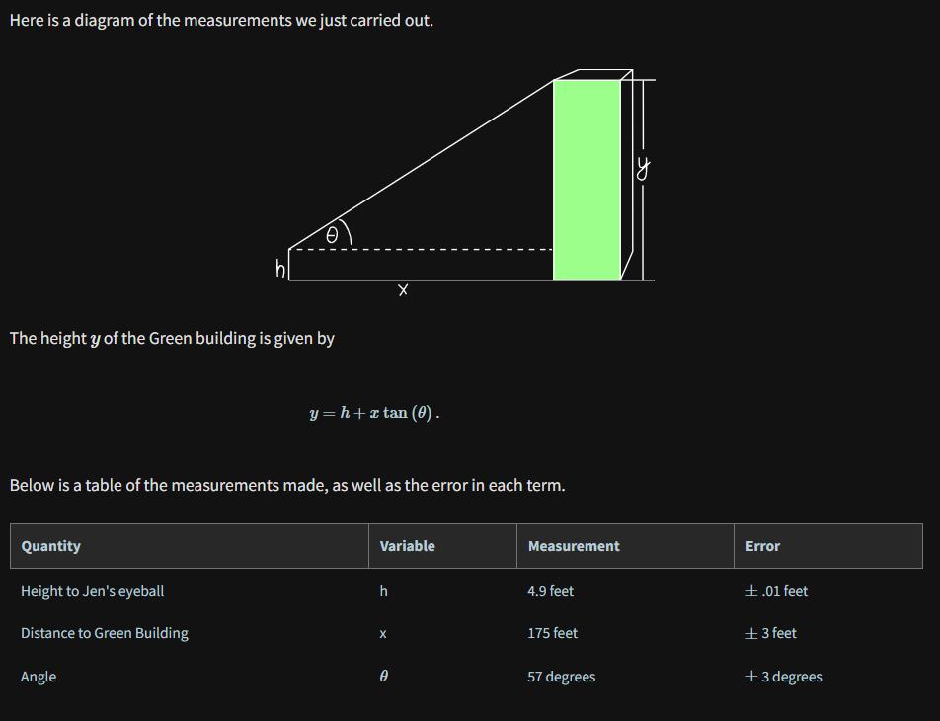

Where is the error coming from?

* The error in the measurement of Jen's height comes from rounding error and inherent error in using a tape measure to enough accuracy.
* The error in the distance to the Green building is coming from a few places: error in the actual length of the rope which may differ by a few inches, error in our walking in a perfectly straight line as we measure, and error coming from the fact that the rope is stretching when we pull on it, lengthening the rope. So in fact, we expect our measurement is likely an overestimate.
* The error in the angle is coming from wind and the string not hanging straight down, error in the construction of the device, and error in holding the device to read the measurement.

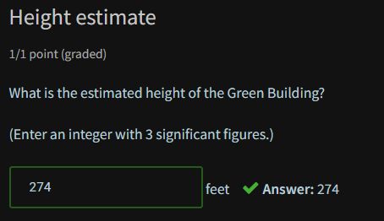

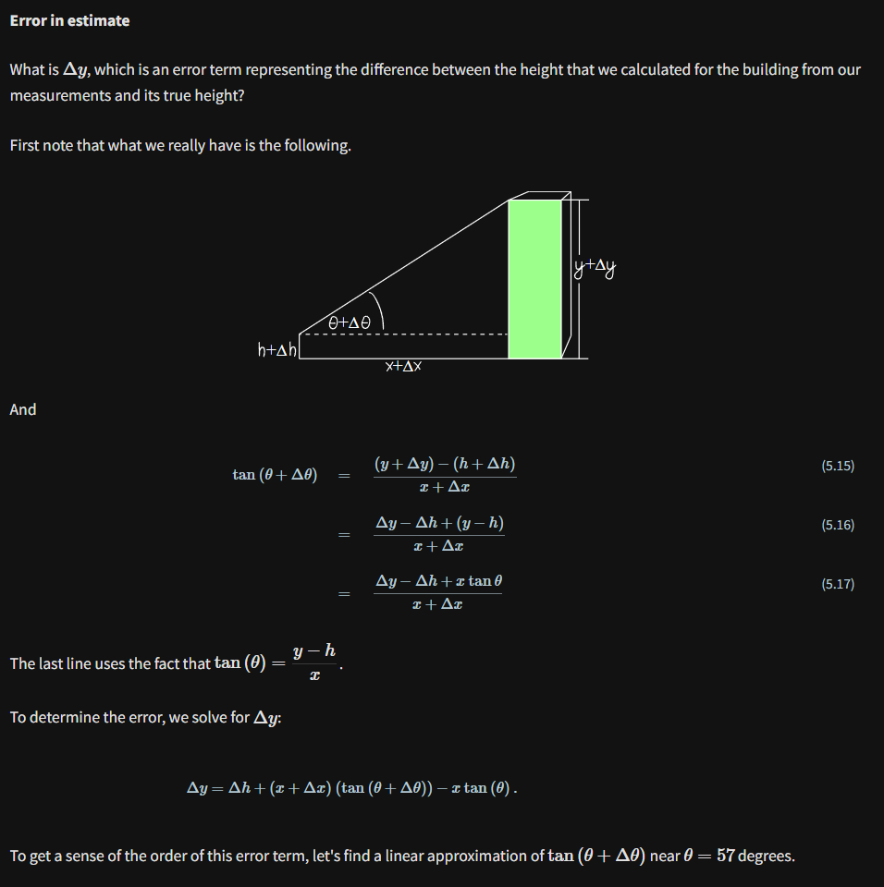

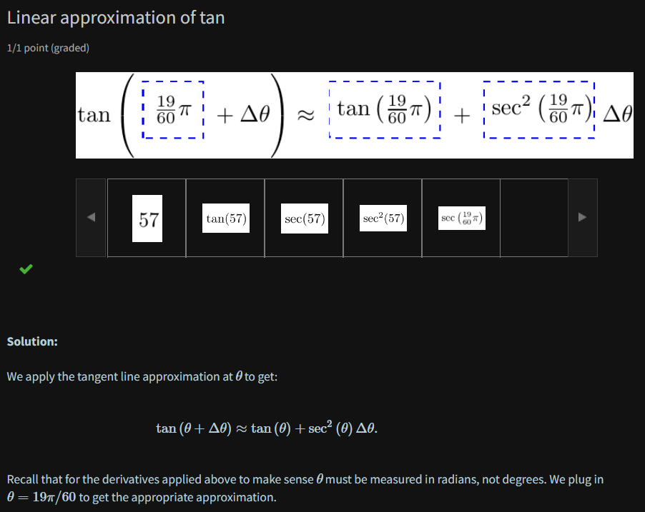

Continuing the error estimate

